Paging

- Paging and Virtual Memory – Used to avoid fragmentation.
  - Basics – Each process has a page table.
- PageNum = logical address/pageSize;
- FrameNum = pageTable[pageNum].page
- Offset = logical address – pageNum*pageSize
- Physical Address = FrameNum * FrameSize + Offset

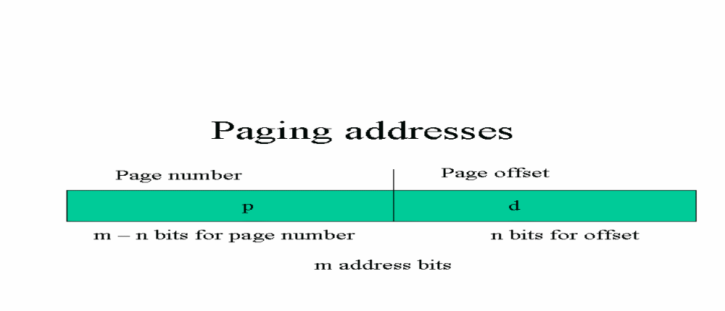
Page sizes are usually kept to be a power of 2, typically between 512 bytes and 16 megs. This makes page and offset calculation a matter of shifting bits.

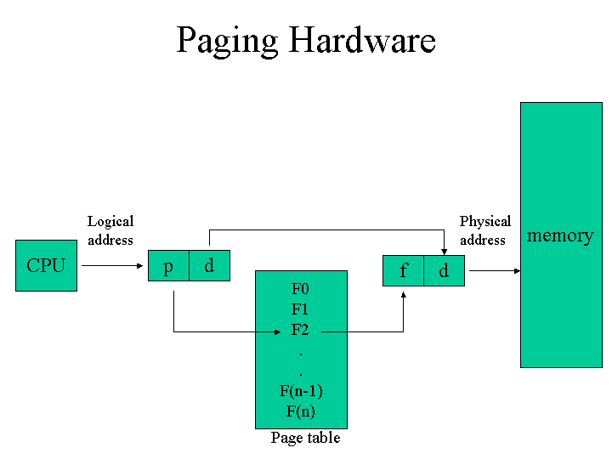
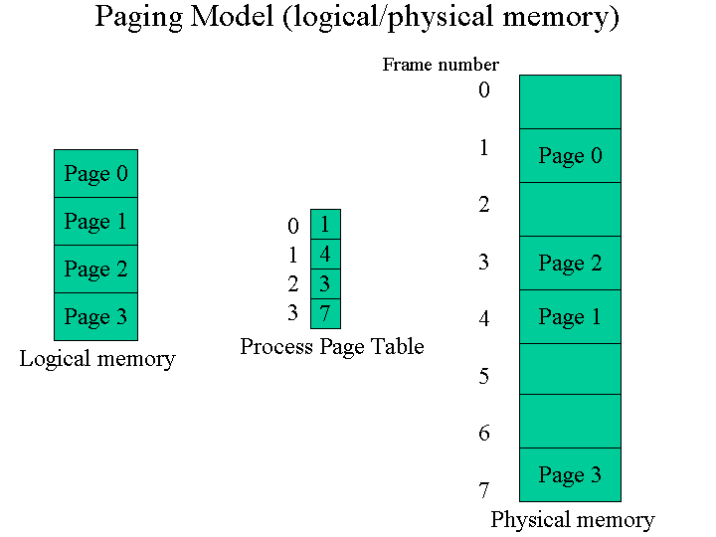

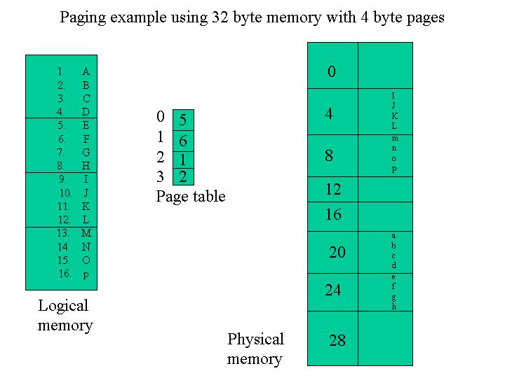

Paging attributes:
- Form of dynamic relocation.
- Logical addresses bound by paging hardware to physical addresses.
- No external fragmentation.
- Any free frame can be allocated to any process that needs it.
- Will have internal fragmentation on last frame of process.
- Page size is a compromise between wanting to minimize internal page fragmentation and minimizing the number of disk accesses, and the overhead required to store the paging tables.

